List of Figures;
- Figure 1. Sample figure.
- Figure 2. Page layout and format.

Figure 1. Sample figure.

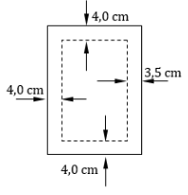
Figure 2. Page layout and format.

